Domain-Driven Design – Task 2
Youssef Wagih – IDA

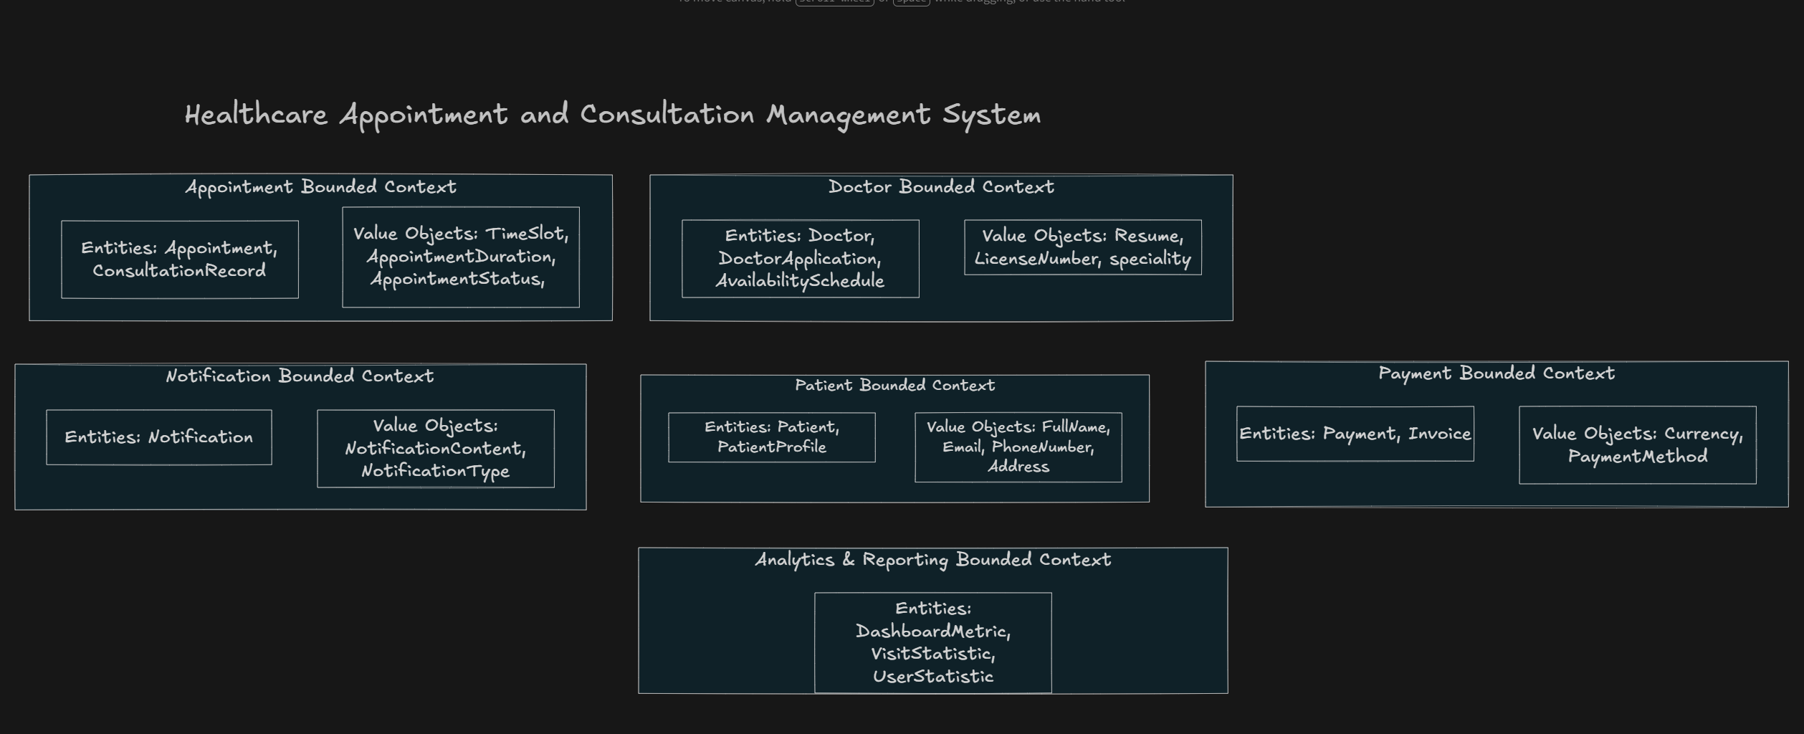

Appointment Bounded Context

Aggregate
Appointment Aggregate (Appointment, ConsultationRecord)

Aggregate Root
Appointment (AppointmentdID, PatientID, DoctorID, ….. etc)

Entities
- Appointment (Aggregate Root)
- ConsultationRecord

Value Objects
- TimeSlot
- AppointmentDuration
- AppointmentStatus

Domain Events
- AppointmentBooked
- ConsultationRecorded
- AppointmentCompleted

